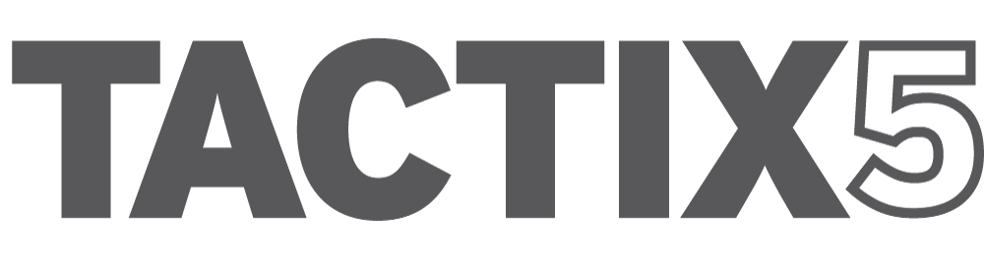

Web Development Questions
Updated: February 14, 2019

To be completed by client when they are looking to develop a new website or re-develop an existing one.

- Company Details
- Describe your target audience.
- What is the purpose of the website?
- What are your corporate core values and how do you express them to your visitors?
- What makes you different from your competitors?
- Why should people do business with you rather than your competitors?
- Do you have specific company colors that need to be used?
- Can you provide the Pantone numbers for your company colors? If so please provide.
- Do you have any other materials that the site needs to match with in some way (brochures, press materials, etc.)? If so please provide.
- What do you like most about your current website?
- Is there any functionality or options on your current website that you plan to keep (other than the content)?
- What are your top 3 frustrations with your current website?
- Do you have social networks setup? (Facebook, Twitter, etc.) If so, please provide links.
- Do you need social media set up for your business? If so, Facebook, Twitter, LinkedIn, Pinterest, Instagram, Snapchat, other?

- New Website
- What do your current competitors’ websites have that you wish to have? Provide a list.
- Are there any websites with designs that you like? Provide links.
- What about those websites would you like to have incorporated into your website?
- What types of things do you see on other websites that you really like?
- What types of things do you see on other websites that you really hate?
- Name the 3 things that are most important in the design of your new website.
- Name the 3 things that are least important in the design of your new website.
- Provide links to 3 websites that have your desired functionality.
- Who is your current website hosted with (i.e. Google, GoDaddy)?
- Can you provide usernames and passwords?
- Who will be involved on your end in the development of the website?
- Who or how will you be managing website upkeep?
- Do you have a budget you are trying to meet?
- Does your current web host meet all your new website’s needs (space, bandwidth, databases, etc.)?
- Do you plan on or need to move to a new host provider?
- Do you need help finding the right web host?
- Do you already have a URL you plan to use?
- If not, do you need help selecting and registering a good URL?
- What types of actions do you want your visitors to take on your website?
- What is your time frame for total project completion?
- Do you have a list of specific pages that you would like to include?

- Content / Approvals
- Do you have a tagline you wish to use or do you need help creating one for your site?
- Do you have the content for the website or will content creation be a part of the scope of work?
- How many pages of content will need to be developed?
- Who will handle approvals of content?
- Will there be any cross promotion of content within the site?
- Please provide details on content cross promotion.
- Will we be importing and formatting your content, or do you plan to do this?
- Do you or your team need training for making website updates, content publishing guidelines, etc.?
- Do you have any specific photos you plan to use?
- Do you have the rights to use those photos?
- Can you provide hi-res files to us?
- Will we need to find stock photos and/or create any images for the website?
- Will video or audio be a part of the new website?
- Can you provide us the proper files or is creation of this content part of the scope of work?
- How many videos or audio files will be added and/or created?
- Do you have any other media or PDF documents that need to be incorporated, or will any need to be created?
- What information must be on the home page?
- What information must always be visible?
- What features, sections or information do you want emphasized on the site?
- How would you like that to be featured?

- Creative / Design
- Do you have a logo you plan to use or will one need to be created?
- If you have one, can you provide the original artwork files?
- Will you need a favicon created?
- Will different sections of your site require different designs, layouts or coloring?
- Will you be offering advertising on the site?
- How should that be implemented?
- Will any customizations need to be made such as optimizing for search, adding content overlays, customized wrappers, etc.?

- Development
- Do you require online chat features?
- Will your visitors require any special needs (i.e., screen reader ready, larger fonts)?
- Do you have any specific mobile requirements?
- Do you require your website to be developed in another language?
- Are you supplying the translated copy or do we need to translate?
- Do you have a content management system (CMS)?
- Are you in need of an upgrade?
- Do you have a preference for which CMS to use? (i.e. WordPress, Joomla, Drupal, Concrete 5, Magneto, DNN, etc.)
- If not, do you need help selecting the best CMS for your needs?
- Does your site need a blog?
- Are you looking for keyword optimization beyond the design/development?
- If optimizing for search (SEO), what keywords/phrases would you like to use?
- Will users need to log in to your site for any reason?
- Do you need any password protected areas?
- What kind of content will be put behind password protected areas?
- How many web forms does your new site need?
- What is the purpose of each?
- How do you want the submitted info handled? (email, database, etc.)
- Will you need an events calendar feature?
- Do you need any social sharing features built in (tweet, like, share, etc.)?

- Ecommerce
- Will you require e-commerce to be setup?
- If so, how many categories and products will you have?
- How many variations of products will you have? (i.e. sizes, colours, types, etc.)
- Do you have full descriptions, images, shipping dimensions and weights of all products?
- Which courier do you intend to ship with?
- Will you offer in-store pickup?
- Will you offer free shipping?
- Do you intend to make use of coupons or coupon codes?
- Whom will your e-commerce cater to? (US, Canada, Worldwide?)
- Do you have a bank account setup for ecommerce? Does it accept CAD or US funds or both?
- Do you have a payment system in place to handle online payments? (I.e. Stripe, PayPal) if so, pls provide account numbers.
- Do you need us to setup a payment system for use with your site?
- Can you provide us with the banking information for setup? We would also need a copy of the owner’s official ID for verification with the payment system. (i.e. Driver’s License)
- Will you require shoppers to create and login to an account to make a purchase?
- Would you like to have abandoned cart functionality? (i.e. shoppers will receive an email reminder about an item(s) left in their cart with an ask to complete purchase).

- Advanced Questions
- Do you have a completed site architecture for the new website or will this be part of the scope of work?
- How many pages will the finished website be (estimate)?
- Will you need multiple levels of access?
- Do you need to be able to manage content publishing approval processes?
- Will there be any third-party applications that need to be integrated?
- Do you have any subscription services?
- Do you use a third party for any part of subscription content delivery and/or payment?
- Do you require printer friendly options?
- Do you wish to employ any “content-on-demand” features (i.e., hidden elements that are made visible with certain actions)?
- Do you need an internal site search feature?
- Do you want contact phone numbers prominently displayed?
- Do you require a database?
- What specific functionality will it need?
- Do you have a Google Analytics account? We’ll need login & password for access.
- Do you have any other specifications or need specific functionality that has not been addressed?

- Things You Need to Know
TACTIX5 develops websites for the WordPress platform.
We charge a monthly hosting fee of $49 monthly, invoiced on the 1st of each month.
Ecommerce setup: $1,500 (includes setup with STRIPE for payment processing) one-time fee.
Shipping estimates as provided by Canada Post in Canada.
Logo development budget: $1,000, Tagline development budget: $1,000 OR combined: $1,500
Social Network setup: $500 each (includes images), Four Pack: $1,200, Five Pack: $1,400

